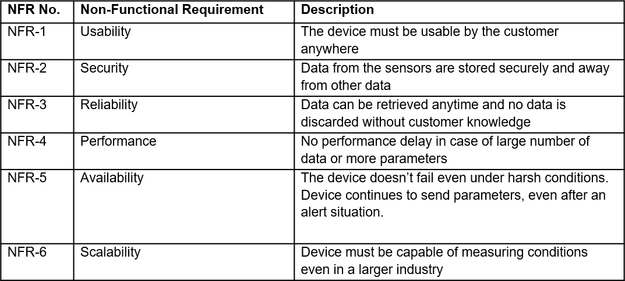
Project Design Phase-II
Solution Requirements (Functional & Non-functional)

Date | 16 OCTOBER 2022
Team ID | PNT2022TMID12971
Project Name | GAS LEAKAGE MONITORING AND ALERTING SYSTEM FOR INDUSTRIES
Maximum Marks | 4 Marks

Functional Requirements:
Following are the functional requirements of the proposed solution.

FR No. | Functional Requirement (Epic) | Sub Requirement (Story / Sub-Task)
FR-1 | User Registration | Registration through Form  Online Payment for the service
FR-2 | User Access | Access the details using web browser  Access the details using mobile application
FR-3 | User alert | Gets alert as an SMS message  Gets alert alarm in the working area.

Non-Functional Requirements:
Following are the non-functional requirements of the proposed solution.

